

DaleelHTU

Prepared By:
Ahmad Amasha – 22110095
Mohammad AL-Shenaiwer – 22110066
Omar Saifan - 22110399

Supervised By:
Dr. Razan AlQuraan

Project Submitted in partial fulfillment for the degree of Bachelor of Science in Cyber Security & Computer Science

Fall-2025
Table of Contents

1.1 Background 3
1.2 Motivation 6
1.3 Problem Statement 8
1.4 Related Work 9
1.5 Discussion 11
1.6 Project Deliverables 12
1.7 Project Tasks 12

Table of Figures

Figure 1: Gantt Chart 4

Table of Tables

Table 1: Project Tasks Description 4

1.1 Background

The HTU student portal is a website where different users with different roles can access it and do different actions based on the role of that user, our main focus with this project is to enhance the student user role, enhancing the experience of the students and the portal in some aspects. Within the student scope the student can add courses, view courses, select certain sections for his courses based on his likings, the student uses the portal to pay for his tuition, view his stats such as, scores, absences, and many more, for this user we will add many more features making the experience of students much smoother especially with newer students that have a hard time figuring things out.

The current portal works fine in doing all the mentioned features such as course management, payment management, fetching and returning information. Mostly things are static or changeable through administrative privileges.

However, our idea is to fix the missing features that are pain causes for students especially newer ones. This will be done through the following features,
- enhanced AI based course management: This feature includes many points to mention such as.
- Building an AI based rating system for the courses, The AI will return a percentage of how good the table of courses is based on the data he was fed, it will generate metrics that are related to the semester courses, and return a rating out of 100. For example, a student that chose all hard and very time consuming courses together with a high number of hours, it will analyze it and give it a rating of how hard it will be and return a percentage out of 100 of the table of courses, it also will generate a number of different semesters the student can take help from to make his semester better and smoother.
- From that same AI system another page will include entering the number of course hours the student wants, and a prompt to help the AI choose the student courses based on his likings, the AI will return a list of courses for the student to get help from based on his prompt and hours.

- AI Chatbot Assistant: This feature consists of 2 chatbots, one for students enrolled in HTU, and one for the users inquiring about HTU.
- The Chatbots that are accessible within the portal have different sets of data such as all portal functionalities so it will be able to help student inquiring on the students portal. It will also have data around other HTU processes, for example, enrolling in the HTU with a certain grant, how will this grant apply to the HTU…etc.
- The other Chatbot will be accessible for everyone even those who are not connected to HTU, it serves the purpose of answering questions for outsiders of HTU, for example, an individual wanting to enter the HTU as a student what are the steps, and so many other questions for outsiders of the HTU that have an interest in the HTU.

- Course trading system: For students wanting a better section or even different courses.
- This feature will be made through blockchain technology of trading different sections or courses, the student can put a course for someone to trade it with, and if the requirements of the other end of the trading process accepts that course and section he can simple trade with that course, this actions does not require students to be online only one of them to trade the course. This is better than students trading manually and searching for someone to trade with which does not really work the majority of the time.
- This feature will be made through blockchain technology of trading different sections or courses, the student can list the course they wish to trade for with someone else and select all the courses they are interested in. Other students who own the desired courses can reviewer the offer and initiate the trading process, once both students agree in the offered courses the blockchain system processes and complete the trade ensuring transparency, security, removing any risks from losing the courses through the tradition way the student go for these days

- Announcements System: This feature will be accessed for all roles of the portal; however, the ones who can announce are limited.
- Club leaders, admins, professors, and more will be able to write announcements instead of sending emails which usually are not seen and not restricted at all.

1. Enhanced AI-Based Course Management
Problem it solves:
- Students often build unbalanced schedules (e.g., all difficult/high-hour courses in one semester) without knowing the impact.
- New students especially struggle to know which courses to pick or how many hours is too much.
- There’s no intelligent help or feedback when selecting courses — only trial-and-error.

Tech Opportunity:
- Use of AI (e.g., LLMs + prompt logic + academic rules) to evaluate course load difficulty and return recommendations.
- Smart scoring out of 100 gives instant feedback based on historical performance data, time blocks, and known course challenges.
- AI can help students by generating ideal course combinations based on constraints (e.g., number of hours, course type, morning vs evening).
- Adds personalization, something static portals can't do.

2. AI Chatbot Assistant
Problem it solves:
- Students waste time looking for answers (e.g., how to register, how to apply for a grant).
- Newcomers struggle with portal usage, missing important deadlines or steps.
- Outsiders (prospective students) have no interactive way to get information; they rely on outdated websites or hard-to-find contacts.
Tech Opportunity:
- GPT-style chatbot trained on HTU rules, policies, and portal functions can instantly answer questions 24/7.
- Two chatbots = one internal (for students) + one external (for prospective students and visitors).
- Helps automate support, reduce email load, and enhance access for both current users and new prospects.
- The chatbot can be deployed inside the portal and on the public HTU website using APIs or widgets.

3. Course Trading System
Problem it solves:
- Right now, students trade sections manually (e.g., via WhatsApp or hallway talk), which often fails.
- No official system exists for students to request or accept trades — it’s chaotic.
- Trades require both students to be present and coordinated, wasting time and effort.
Tech Opportunity:
- Use blockchain or smart-recorded logic to track trade requests and approvals securely.
- One student can place a trade request, and the system matches it asynchronously with a suitable trade from another student.
- No real-time coordination needed — just set-and-forget.
- This creates a structured, fair, auditable system for course trades.

4. Announcements System
Problem it solves:
- Announcements are now mostly sent via email, often ignored or never seen.
- No central feed of student-relevant news inside the portal.
- Clubs and professors can’t directly reach students in a structured way.
Tech Opportunity:
- A portal-integrated announcement system allows targeted, role-based communication.
- Club leaders, admins, and faculty can push updates that students see inside the portal.
- Can support rich content (images, attachments) and time-based expiry.
- Encourages better campus engagement, fewer missed events.

1.2 Motivation
For each feature there is a motivation and a need to solve the problem, in general the enhancements serve the purpose of making the HTU portal a better system, and with these features it will be even better, especially now it will be combined with AI features. These are the motivations for each feature solving different problems.

- enhanced AI based course management:
- The motivation behind this feature is making things easier for students in terms of course selection, and for the students to have the best possible list of courses in their terms, this will affect them positively in terms of grades, controlling the courses in terms of studying which means actually going through a semester finishing with good grades and being able to study and balancing the semester courses and getting the best grades possible on a balanced list of courses for the semester.
- Helping newer students within their courses on what courses to add, usually newer students “Sanafer” have no clue on what courses to select for their whole first year, so this will actually be very useful.
- Finally, this feature will help even students who are 3rd or 4th year in terms of graduating, the AI system will fetch courses as recommendations also based on the courses that are left for the student and how much the student has completed, helping the student to graduate within the 4 year window.
- AI Chatbot Assistant:
- The first motivating point of making the Portal Chatbot assistant is to help student in their university processes, newer students probably will not know basic things such as how to manage their courses, where to find their grades, how to calculate their grades how much does an “M” score is on a GPA, their basic questions and sometimes are actually a need, such as “how to pay to add courses”, all will be answered through this Portal Chatbot. Not to forget also that it does help 3rd and 4th year students answer questions such as, what is the processes of graduating and taking the Uni certificate and so many questions that may come to mind.
- The second motivating point will be helping individuals outside of the university, this includes parents, possible students, or individuals of interest about the HTU. If parents have questions in mind about the university they can communicate with out chatbot and it will answer their questions, the same goes for possible students who look forward to enroll in the HTU, they can get all their questions answered, for example interested parents or possible students can ask about the apprenticeship training period and all about it, and of course many other questions.

- Course trading system:
- The first motivation for this feature is to help the students which have problems in changing course sections or courses. Currently to do this, most of the time students use WhatsApp groups, asking their peers or waiting for someone to drop out of the course at the time they need it. This way for changing courses is stressful, unpredictable, and unreliable due to course section availability.
- A good course trading system will help a student to offer their seat in the course (doing this will provide a secure method of finding a replacement) and request a section or course in exchange. This way the trading functionality gets rid of all the unpredictability associated with the current way of changing courses and relies less on personal networks and contact lists or chance.
- Finally, the introduction of this trading functionality will increase student satisfaction, flexibility, and indirectly their grades. If a student has chosen a bad section time, if it is too early, too late, they can still improve their schedule later through trading. By allowing students to have schedules that better match their needs, it is probable that this will result in higher levels of attendance, engagement, and grades.

- Announcements System:
- This feature deals with the situations where students are missing important information or announcements via their university email account because of them not checking or accessing the account, going through spam, promotions, and other emails “real emails not announcements” that may distract students from seeing Club Events, Notices, Deadlines and University Updates.
- The new process enables university staff, Club Leaders, professors, and students to have their announcements posted in one location - the same place where students access their Course, Grade and Payment Information. This also allows all communications to be in one place making everything centralized. This will fix the problem of having the emails in a place and the announcements in a different place, why should a student have to see a FIGMA verification code next to the announcement of something actually important.
- Lastly the new announcements feature will allow Clubs and Club Leaders to have better visibility for their events and activities. Instead of having to rely on posters or waiting for someone to post a message or email, Club Leaders will have the option of posting all their events or announcements directly to the student portal. Creating a stronger student community increases the opportunities for students to become more engaged in University Life.

- Online Course Offer System:
- This feature is made to help students with a better understanding of the courses that they are in by allowing them access to online resources. Many students have problems with certain areas/topics but they may not know where to get started or what videos/courses they should take for the information they need. This system will reduce the amount of time it takes to find the appropriate resources for each subject area recommended online courses that match each specific subject area on a student's schedule.
- Another motivation point of this feature is to serve different types of students. Some students may have a weaker point and need more assistance in developing their skills, while other students may want to expand upon the material presented in their classroom. The relationship between the universities and the set of online courses listed under each university course allows both types of students to use these resources to learn at their own way.
- Finally, there must be an effort to provide students with safe and organized resources for their education, different than making it easier for them to pop up on random searches across the internet, which cannot be sure of the quality of the content. All recommended online courses will be selected by people of experience.

1.3 Problem Statement

The current HTU portal provides basic services like viewing and registering the courses, checking the grades and managing tuitions payments. All of them are working as a functional static and manual without helping the student in building balanced schedule or choosing suitable courses or understanding university process unless a human interactive got involved. As result, many students, especially first-year students struggle with course selection, registration steps and finding reliable information regarding the courses or the university process with increasing stress and pressure registration period.

Serval specific problems have been identified and fixed. First, the portal does not provide any intelligent schedule support to the student since the student must choose manually the courses and sections without any reliable feedback on the workload, time distribution or difficulty. So, the students will create their schedules without knowing if they can handle them. There is no AI schedule builder rating system to warn the students when they choose too many hard and time-consuming courses in a single semester. Second, there is no integrated AI assistant that can help the student in the university process many students, even in the third and fourth year, could have some questions about university procedures like graduation, scholarship , and more even the first and second year can have common question regarding the grading system HTU portal and GPA rules, deadlines: student depends on friends, social media, doctors and HTU staff and scattered information which can be inaccurate or outdates.

Third, course swapping between students is usually handled through agreement at a certain time both sides drop and add the courses at the same exact moment. The existing system does not support structured student-to-student trading sections which have many issues like unnecessary pressure in the existing server and registration system also it includes a high risk of losing the course during the process.

Fourth, announcements and campus communication are mostly done by email, which many do not check due to the amount of people who send unrelated or unnecessary emails since anyone in the university can send. So important updates from clubs, instructors, and administrators are often missed since there is no central mailbox dedicated for announcements.

Finaly, the current portal does not support any system that helps students find online courses that can help them in their current courses, schedule and academic progress like (Udemy, Coursera, YouTube or similar platform). Students who want to improve their skills for personal development must search manually for the online courses and might waste their time if they started a course that won’t enhance their skills. The current system does not have the feature of recommending a course aligned to the students’ courses and interests or available study time. This leads to missed opulently on skills building, self enhancement, certifications

1.4 Related Work
Recent developments have seen several universities transition their existing student Portals from simple registration websites to complex, integrated platforms where students can plan their academic careers, utilize self-service tools and access Intelligent Support Services. Projects that have demonstrated innovation in several key areas include, but are not limited to; AI-Aided Schedule Builders

AI Schedule Builders allow students to build conflict free study plans that are aligned with their degrees based on the same degree codes that appear on their transcripts. For instance, Texas A&M-San Antonio, Central New Mexico Community College and Purdue University have implemented AI-Powered Tools from Ellucian SmartPlan, which will automatically map all of the courses that are required for students to complete their degree as well as assist in developing multi-year plans based on the students' selected major and personal time constraints. While Artificial Intelligence Tools can flag potential completions for minors and reduce the advisor's workload due to the automaticity of the scheduling process, these tools depend on the availability of quality data and utilize difficult logic rules to create the plans, resulting in mixed implementation success in instances where a university has no portal data.

In addition, many institutions are moving away from using static PDF course catalogs to the use of Dynamic Searchable Catalogs that provide centralisation of information for courses, prerequisites, and programs. As a result, both Discoverability and Administrative Effort are improved by the increased efficiency and effectiveness of these types of Catalog Systems. Research example like, CourseQ took this idea into interactive course recommendation which suggest elective courses to be based on the interest of the student and history of the student, however, production scale recommenders are considered rare to find.

Another significant area of research relates to the design and implementation of AI-driven chatbots within institutional online environments (i.e., website portals) and within communicating channels such as Messenger and WhatsApp. Many universities have developed AI chatbot programs, such as the AI chatbot "Pounce" at Georgia State University. The chatbot sends out personalized reminders about upcoming enrollment tasks and answers commonly asked questions. Evidence indicates that Pounce has decreased the number of students who are offered admission but do not complete their application by an estimated 22% due to their "summer melt" issue. Likewise, many universities have also developed AI chatbots to provide 24/7 access to information regarding registration, deadlines and financial aid (thus reducing staff's need to respond to repetitive inquiries) while allowing students an opportunity to receive answers quickly. However, there remain significant limitations in the currently available implementations of AI chatbots; the majority are restricted to frequently asked questions (FAQs) or admissions assistance; they typically have only a tenuous connection to the student information management systems; and there needs to be continuous monitoring by humans to ensure that correct information is provided and to mitigate the potential for bias and/or privacy violations stemming from the provision of incorrect information. Additionally, new research has explored the use of predictive analysis and early-alert analytics to assist with risk assessment (and course choice recommendations) based on historical data, which also raises issues around fairness and the likelihood that unintentional biases could be perpetuated against certain demographic groups if not purposely designed to mitigate such biases.

Although there are positive developments in this area, several gaps exist that directly impact this project. They currently have systems that allow student-to-student section swapping via some basic functions (drop/add section when available), but there does not appear to be any evidence supporting an actual peer-to-peer trading marketplace where two students can securely trade seats within the system using the portal. Most schools still use either a waiting list or social media to coordinate such trades. Also, many industry leaders recommend that the design of portals be developed first with a mobile view in mind. Pathify, for example, says that students today expect a seamless experience between their mobile device and their web browser. The majority of existing portals lack robust mobile functionality and/or offer disconnected apps that discourage engagement of their users.

In summary, the related work shows that AI supported portal tools that help the students similar to our idea like, chatbots, dynamic catalogs and recommenders are starting to change student portals, but still there are limitations to what they can do, lack of deep integration, and not the most consistent experience. The proposed HTU Student Portal Enhancement Project builds directly on these applications and related work by combining an AI-assisted course management and rating system, integrated chatbots for enrolled and interested people, a structured course trading system, and an improved announcement page, all makes a student-centric portal to HTU.

1.5 Discussion
The selected idea is to enhance the existing HTU student portal by adding five main modules: an AI-based course management assistant, a course offer and recommendation module, an AI chatbot assistant, a structured course trading system, and a centralized announcements system. Together, these enhancements aim to transform the portal from a mostly static information system into a more intelligent, interactive, and student-centred platform that supports planning, decision-making, communication, and flexibility during the whole study journey. This direction is aligned with how modern university portals are evolving to integrate AI planning tools, chatbots and richer self-service features into one unified system.
From a system components perspective, the enhanced portal can be seen as a set of new subsystems built on top of the current HTU infrastructure. At the core, the existing student information system (SIS) and portal continue to handle authentication, user roles, course data, grades and payments. On top of that, the project introduces:
- An AI course management service that reads the list of available courses, difficulty levels and student records to rate a proposed semester plan and show how balanced or risky it is.
- A course offer and recommendation module that analyzes the student’s major, completed courses and remaining requirements to suggest suitable courses for the coming semester.
- An AI chatbot service with two “modes” (internal for enrolled students and external for parents/prospective students) connected to HTU policies and portal instructions.
- A course trading engine that manages trade offers, matching and validation so students can safely exchange sections under the university’s rules; and
- Announcements module that stores and serves role-based announcements (admin, professors, clubs) to students inside the portal.
These components communicate with the core portal and SIS through clear interfaces (APIs or internal services), so they can reuse existing data and be extended later without redesigning the whole system.
In terms of functionalities, each component directly targets a specific student or institutional need. The AI course management module allows a student to choose a draft set of courses and credit hours for a semester and then receive a difficulty rating and feedback. This helps avoid overloaded or badly balanced semesters and supports better academic planning. The course offer module goes one step further: based on the student’s major, what they have already completed, and how many hours they want to take, it suggests a list of courses that fit their path to graduation, including suitable electives. This is especially useful for first-year students who do not know what to pick, and for third- or fourth-year students trying to finish all requirements on time.
The AI chatbot assistant focuses on handling questions and guidance. Inside the portal, the student-facing bot answers typical questions about course registration, how to see grades, how to calculate GPA, what “M” means, how to pay for added courses, and what steps are needed for graduation. The public-facing bot answers questions from parents and prospective students, such as how to apply, grants and scholarships, or how apprenticeship training works. The course trading system provides a formal way for students to post and accept trade offers for sections and, where allowed courses. Instead of relying on WhatsApp groups and luck, the system checks prerequisites, capacity and rules, then performs the trade when a match is found. The announcements system lets authorized users (admins, professors, club leaders) post categorized announcements directly into the portal, replacing scattered emails and making sure important updates are visible in a single, structured place.
Regarding interfaces, the goal is to keep the experience unified and simple from the student’s point of view. All new features are accessed through the existing portal UI with additional pages and components:
- A “Smart Schedule” page where students can build or edit their semester plan and see the AI difficulty rating.
- A “Course Offers” page where recommended courses for the upcoming semester are listed, with clear separation between mandatory and suggested courses, and an option to add them to the draft schedule.
- An always available chatbot panel (for example, a chat icon on all portal pages) that opens the AI assistant.
- A trading marketplace interface where students can create, browse, filter and accept trade offers.
- Announcements feed on the main dashboard, showing the latest updates filtered by role, major or interest.
Staff, admins and club leaders will have their own simple management interfaces for creating announcements and, where necessary, monitoring trading activity and chatbot usage. The design will follow modern portal and UX practices that recommend responsive, mobile-friendly layouts, so that the same core features work well on smartphones and laptops, which is increasingly expected by university students.
Overall, the selected idea is modular and realistic: each component can be developed in phases and integrated step-by-step with the current HTU systems. At the same time, this architecture leaves room for future enhancements, such as deeper predictive analytics or a dedicated mobile app, without needing to rebuild the portal from scratch.

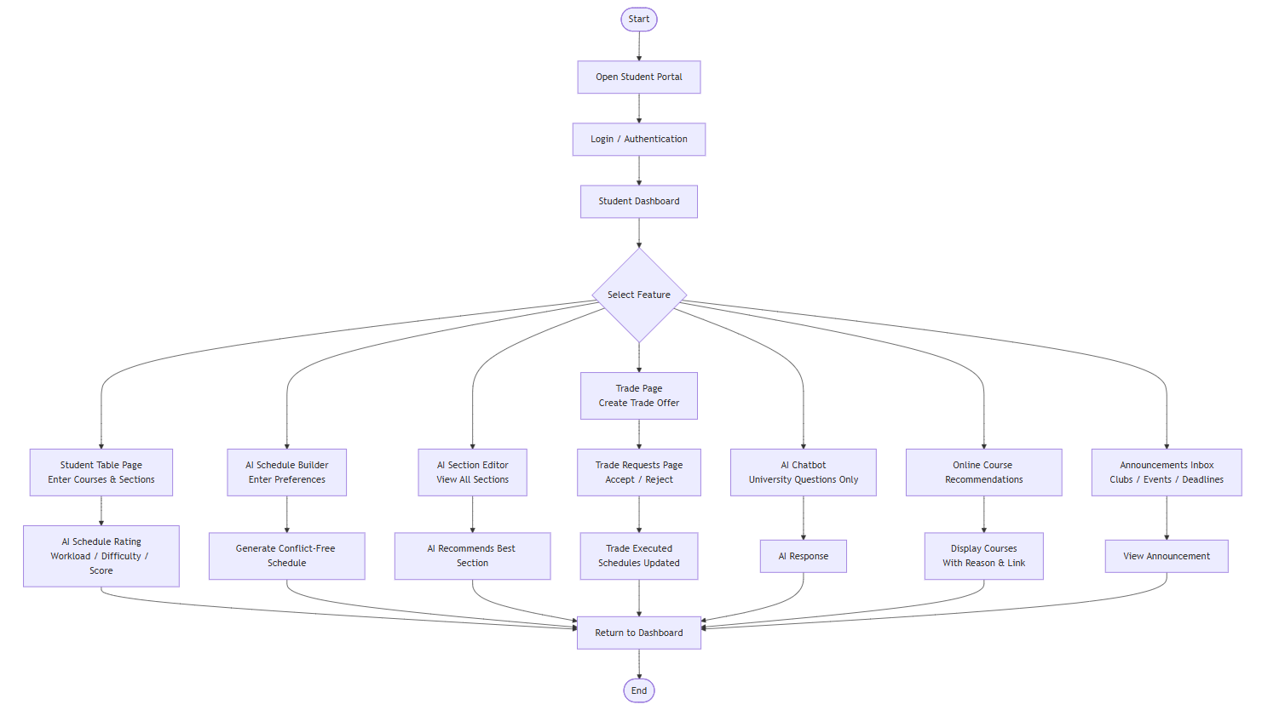
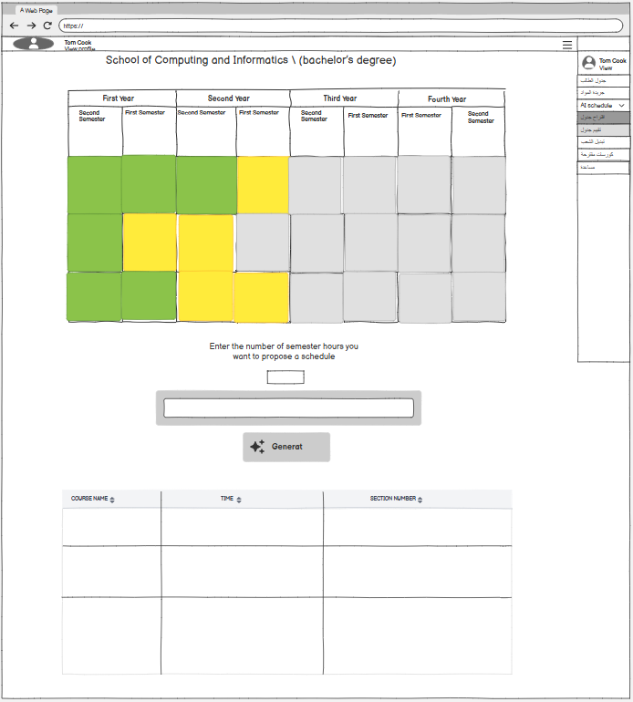
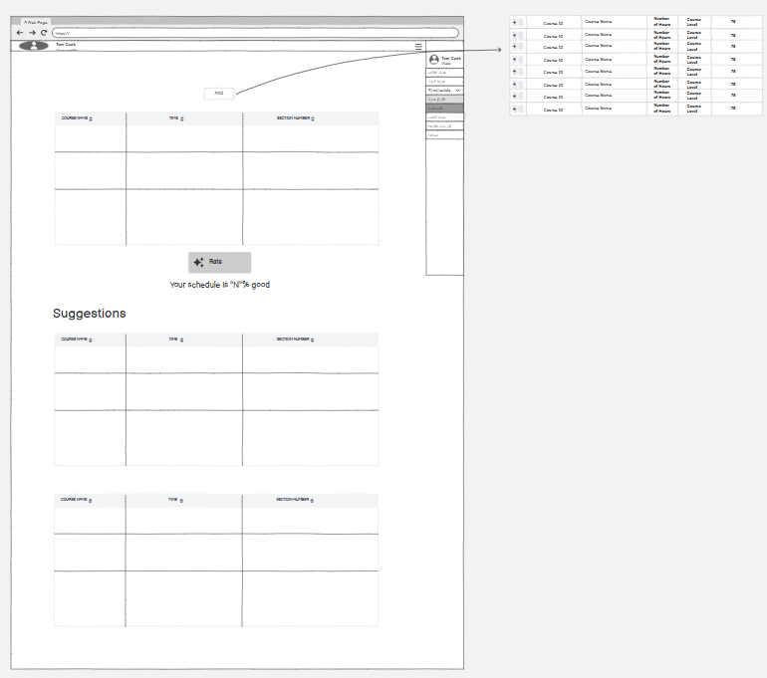
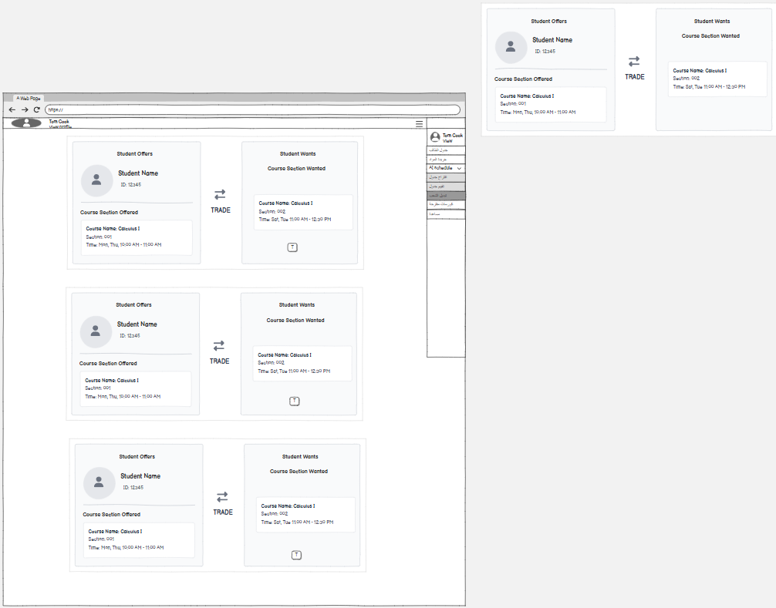
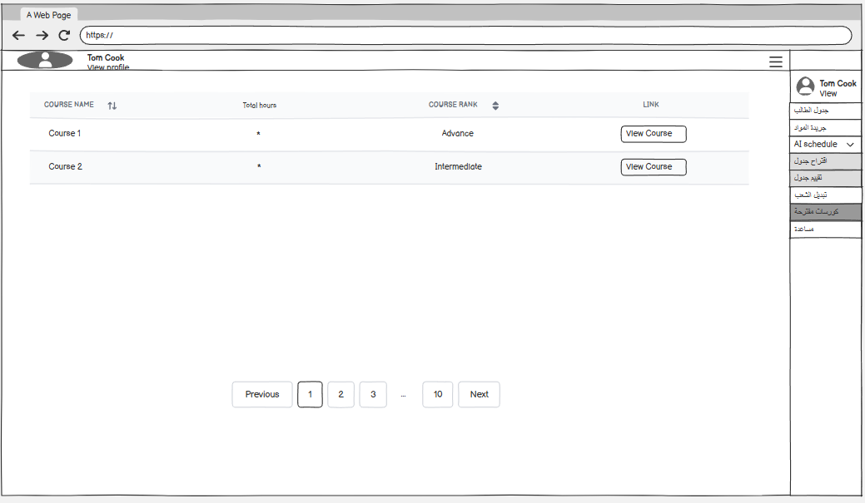
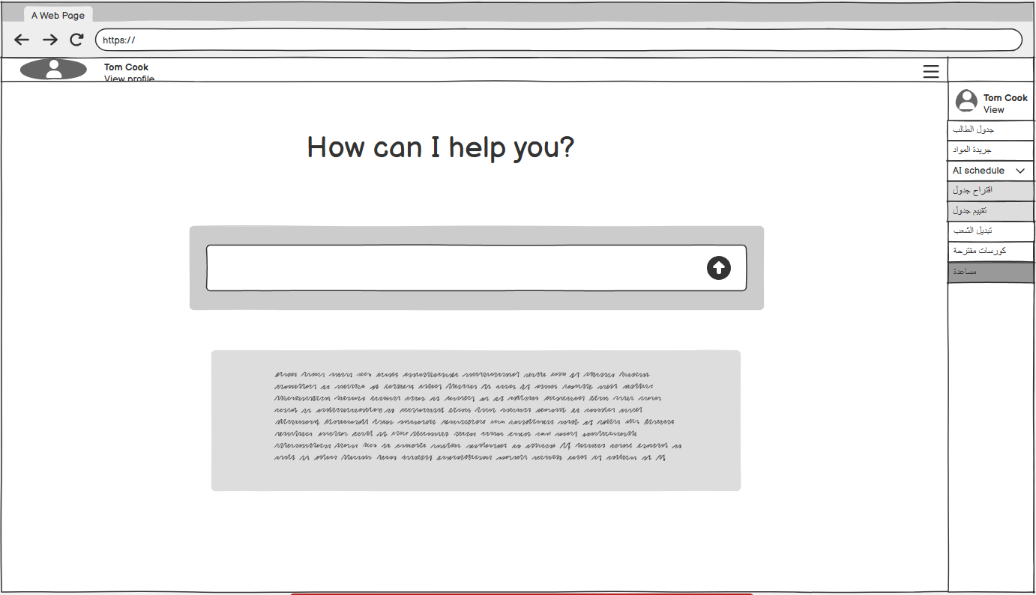
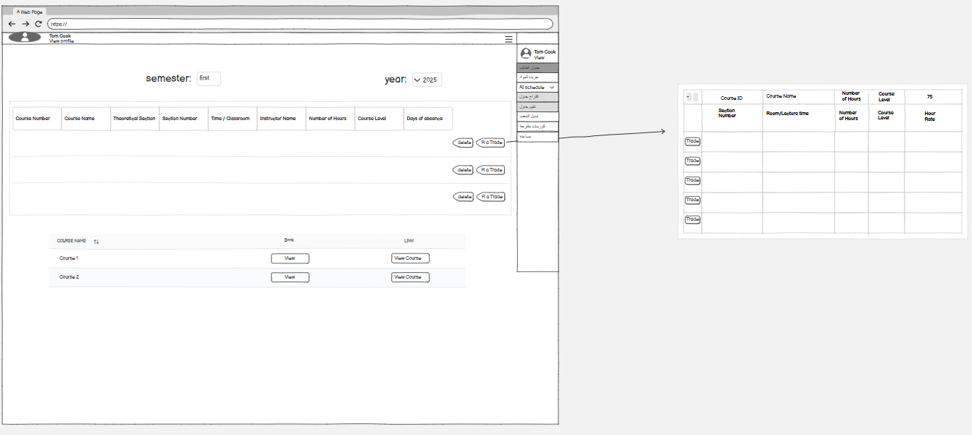
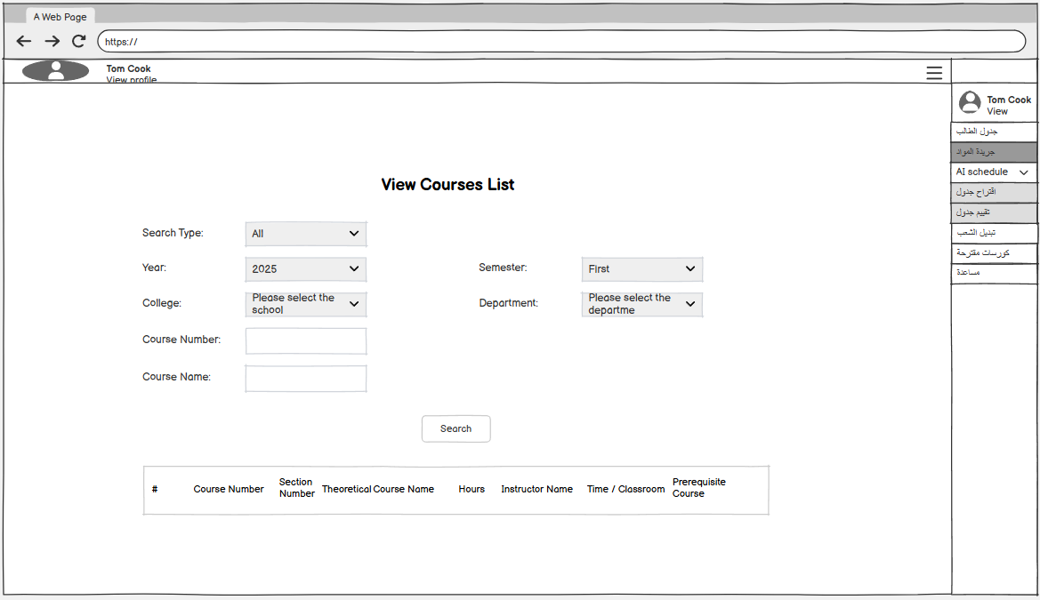
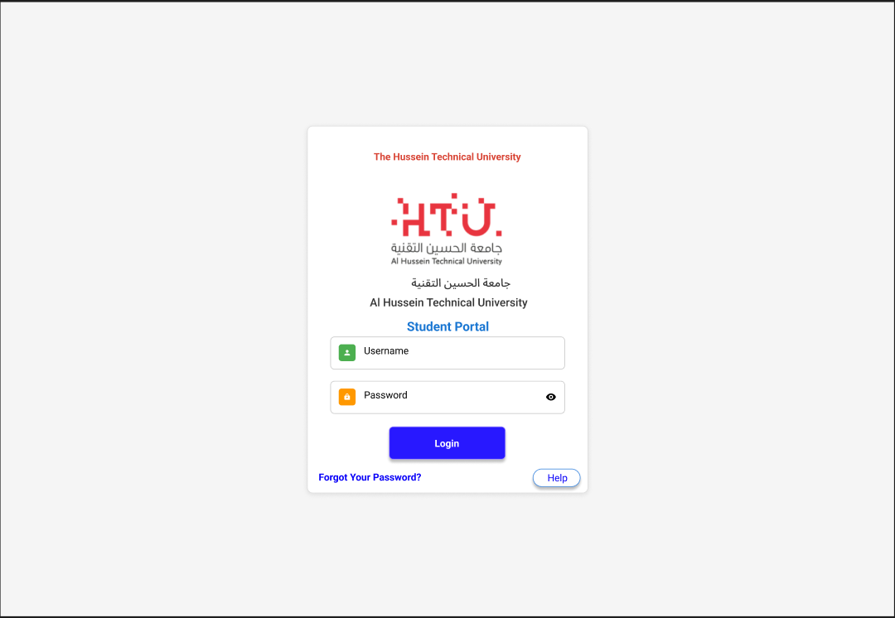
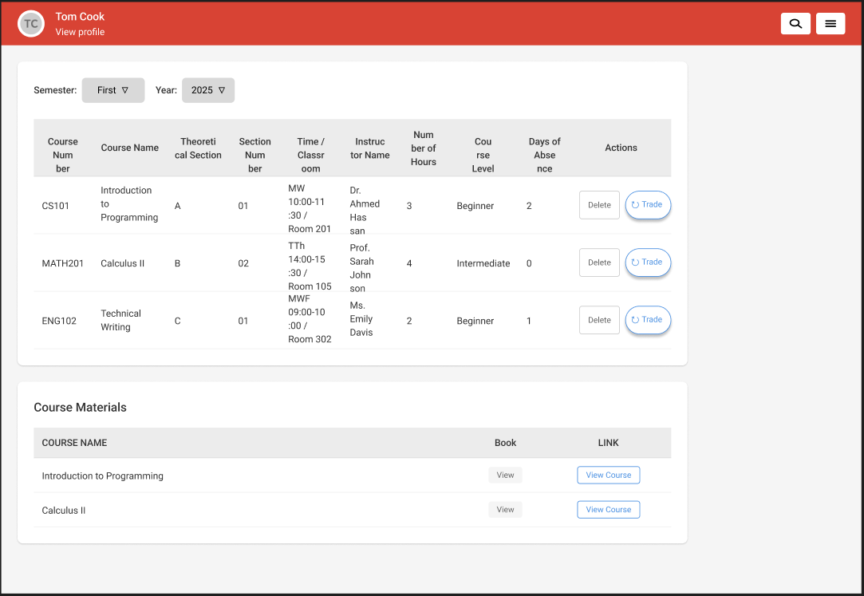
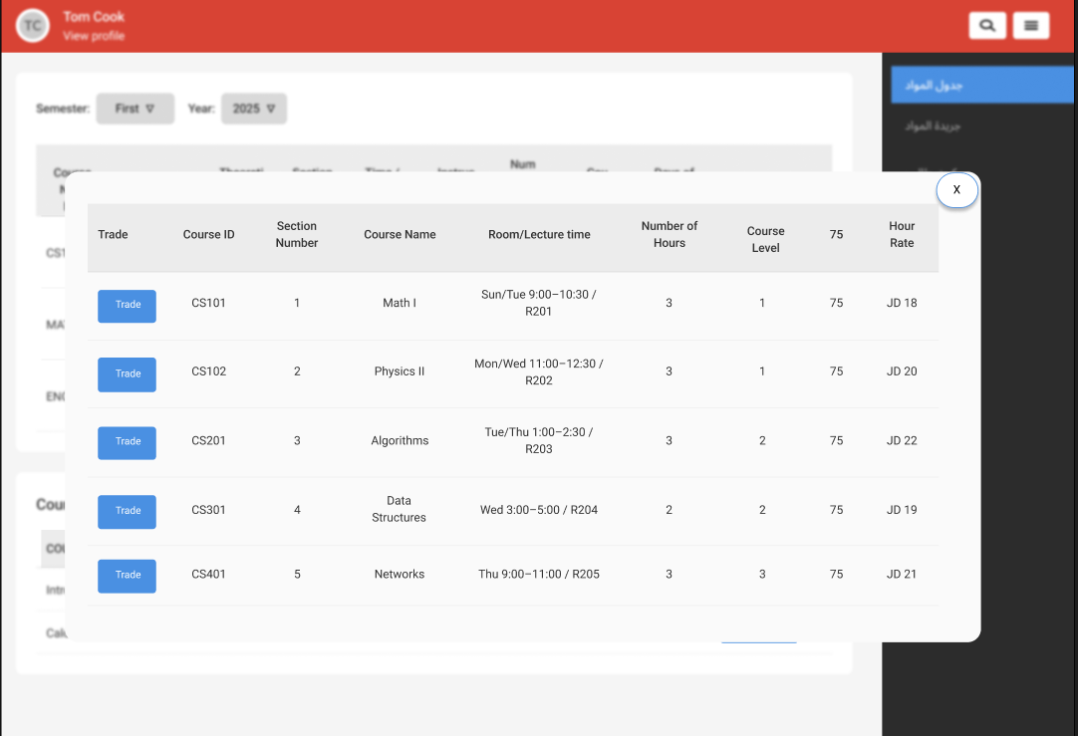
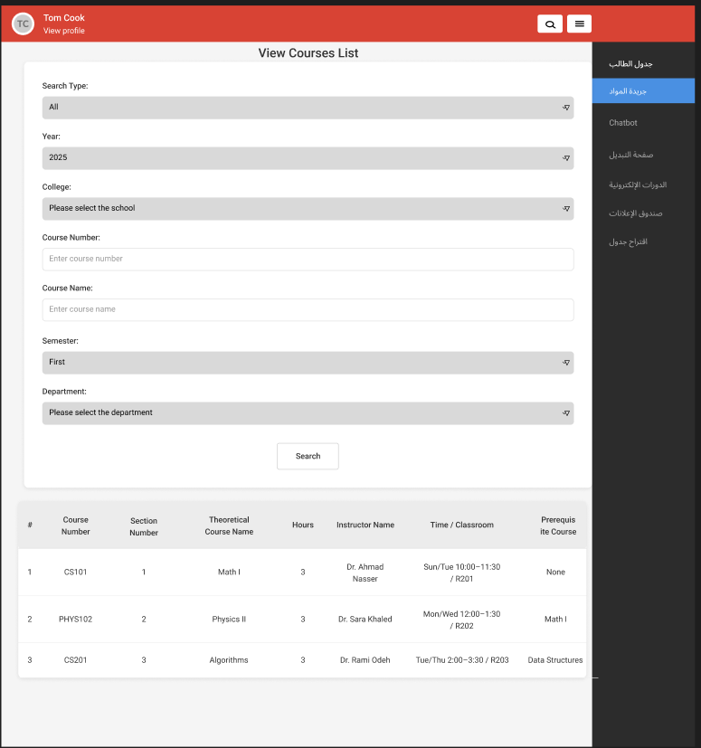
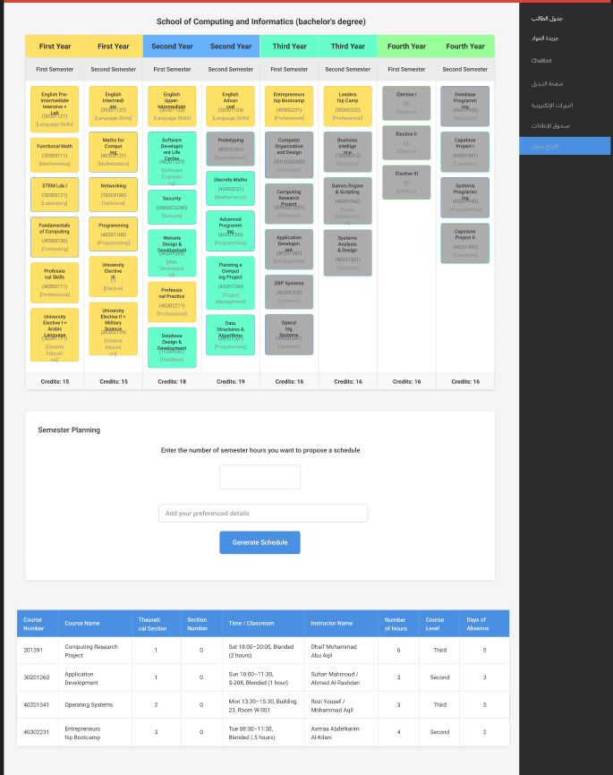

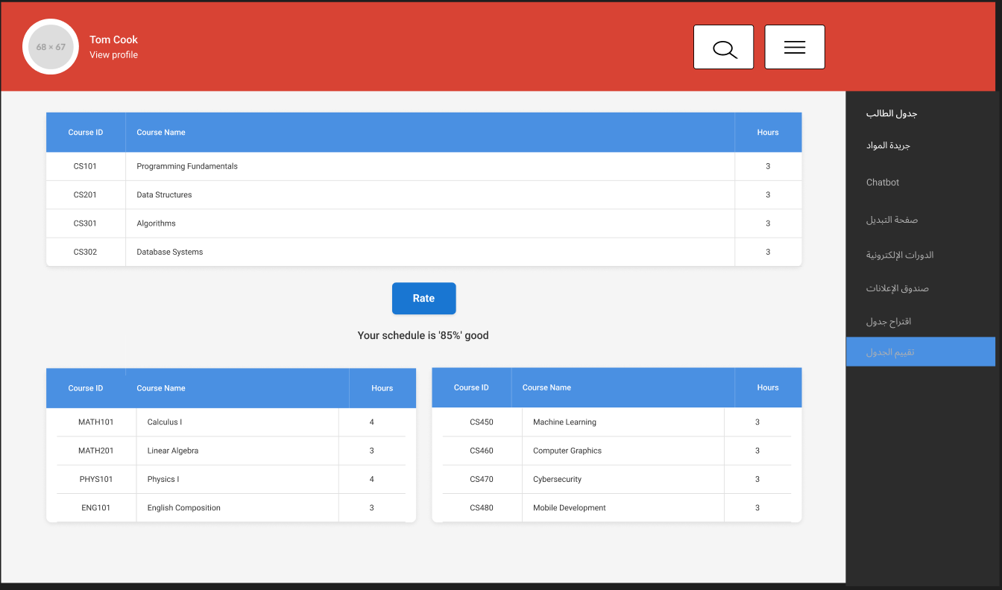

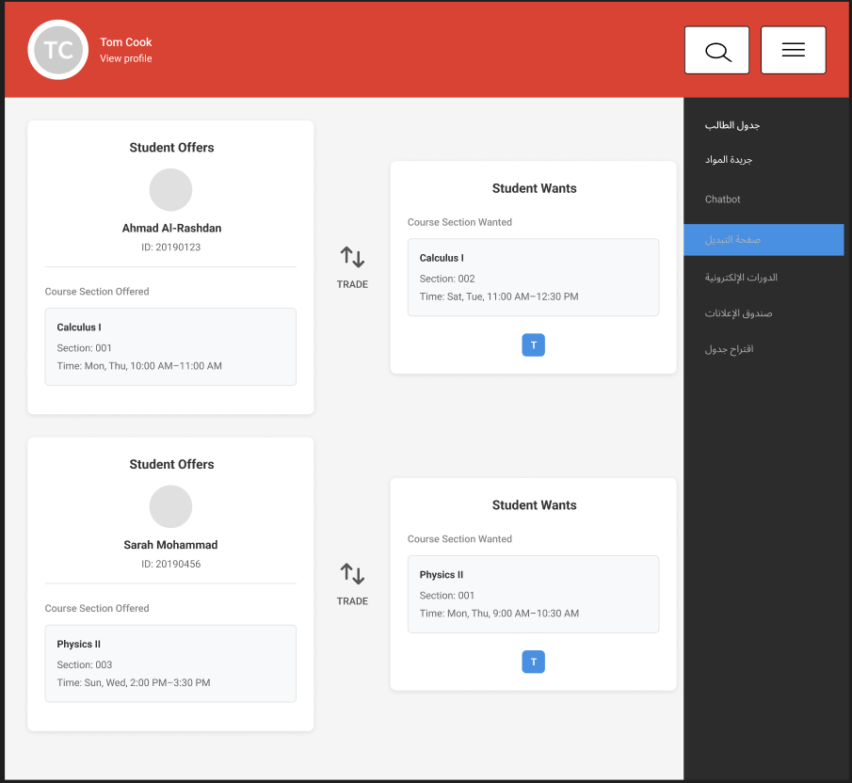
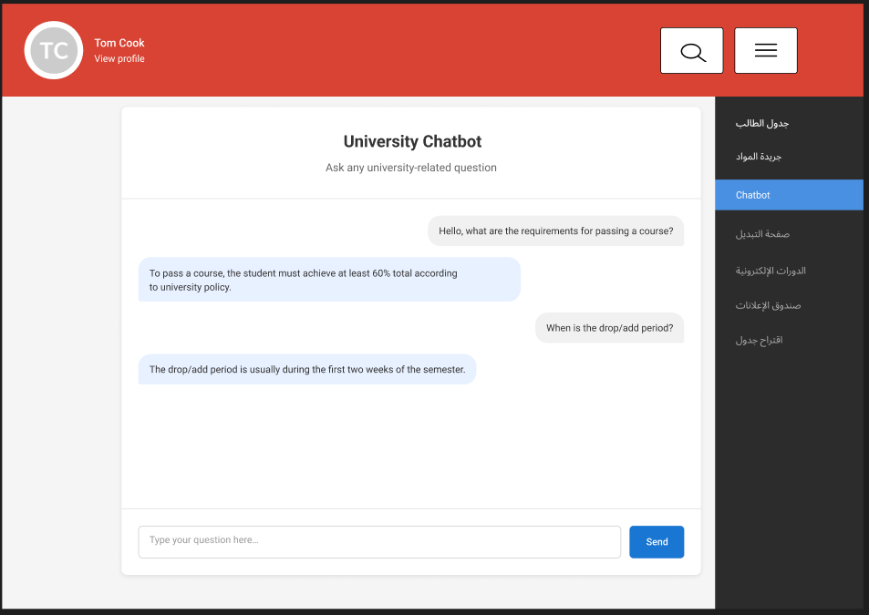
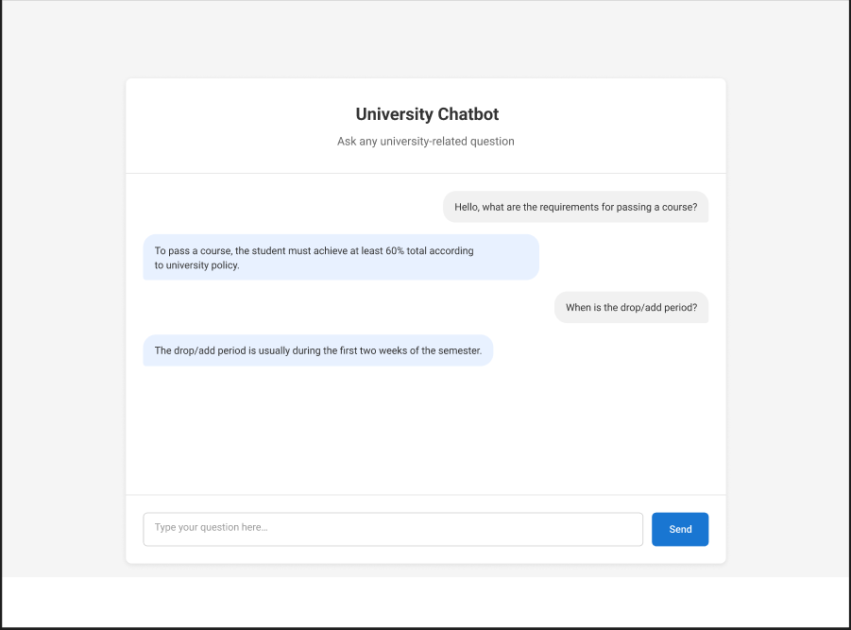
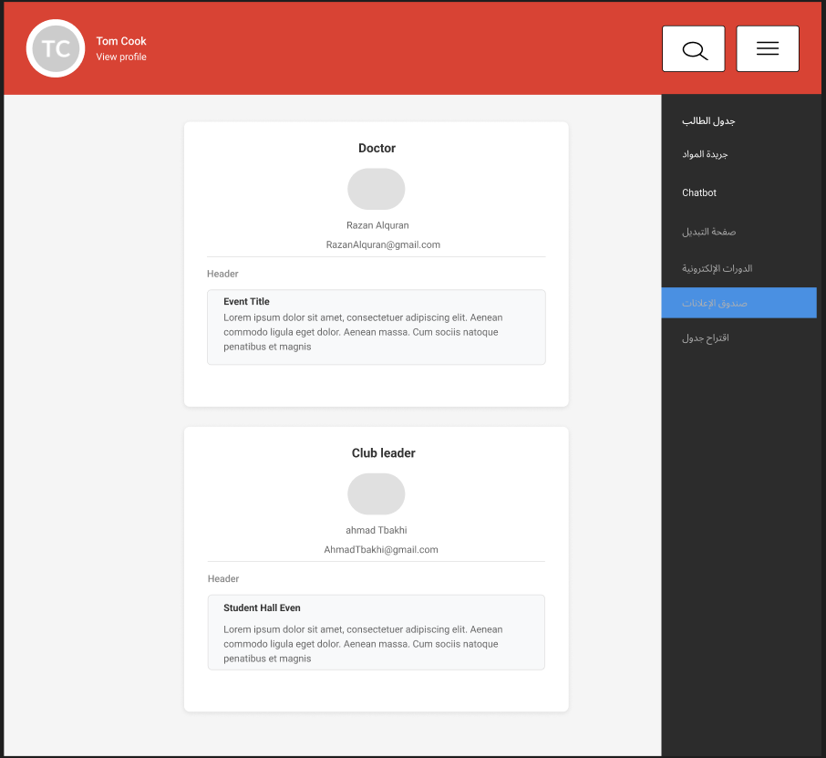
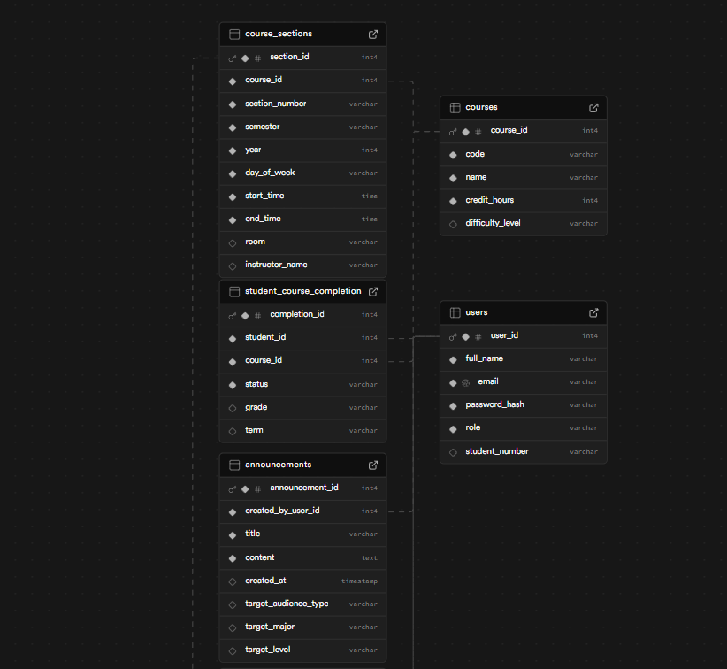
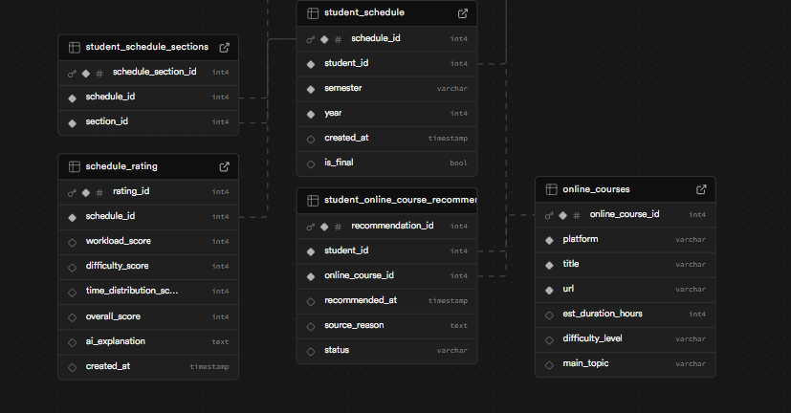

1.6 Project Deliverables
- Documentation file of the project.
- Presentation.

1.7 Project Tasks

Figure 1: Gantt Chart
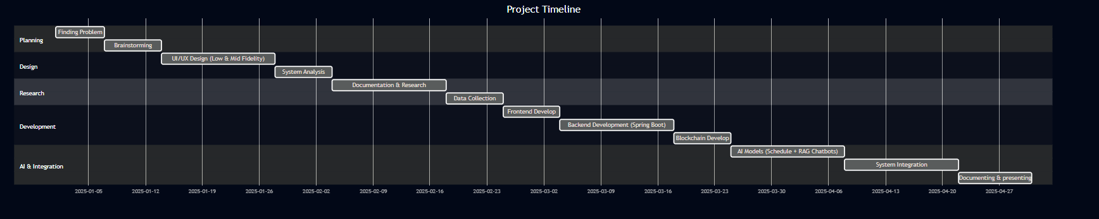
gantt
dateFormat YYYY-MM-DD
title Project Timeline

section Planning
Finding Problem :0001D, 2025-01-01, 2025-01-07
Brainstorming :0002D, after 0001D, 2025-01-14

section Design
UI/UX Design (Low & Mid Fidelity) :0003D, after 0002D, 2025-01-28
System Analysis :0004D, after 0003D, 2025-02-04

section Research
Documentation & Research :0005D, after 0004D, 2025-02-18
Data Collection :0006D, after 0005D, 2025-02-25

section Development
Frontend Develop :0007D, after 0006D, 2025-03-04
Backend Development (Spring Boot) :0008D, after 0007D, 2025-03-18
Blockchain Develop :0009D, after 0008D, 2025-03-25

section AI & Integration
AI Models (Schedule + RAG Chatbots) :0010D, after 0009D, 2025-04-08
System Integration :0011D, after 0010D, 2025-04-22
Documenting & presenting :0012D, after 0011D, 2025-05-01

Table 1: Project Tasks Description
Phase 1:
Task ID | Task Name | Description | Time Duration | Assigned To | Notes
0001D | Finding a problem | Finding a technical problem that does not have a solution | 7 Days | All members
0002D | Brainstorming the solution | After finding a problem we brainstormed to find how to fix it | 7 Days | All members
0003D | UI/UX | Using FIGMA and Balsamiq we have made the low and mid fidelity | 2 weeks | All members
0004D | System Analysis | Using different drawing tools we have designed the architecture of the system | 1 week | Omar and Mohammad
0005D | Documentation | We have documented and gone through different stages of why should we do the project and searching on similar projects | 2 weeks | All members
0006D | Data Collection | We have collected the needed data to feed into the AI model as rag-based models | 1 week still in progress | Ahmad
Phase 2:
0007D | Frontend Development | We will build the frontend based on the UI/UX using React | 1 week | Omar and Mohammad
0008D | Backend Development | We will develop the backend that fits with our needs in spring boot | 2 week | Omar
0009D | Blockchain Development | Building the trade feature using the blockchain technology | 1 business week | Ahmad and  Mohammad
0010D | Building the AI models | Building the AI models for the course registration system and the RAG chatbots | 2 weeks | All members and extra
0011D | Connecting the frontend, backend with all the other features | After developing all the features we want to connect them to the backend and connecting the backend to the frontend | 2 weeks | All members
0012D | Documentation and presentation | After finishing the system we will document it, and make a presentation explaining all its aspects to do the presentation to the capstone | 1 week | All members

References

- Inside Higher Ed (2024) Tech and AI give boost to academic advising. Available at:
https://www.insidehighered.com/news/tech-innovation/artificial-intelligence/2024/06/18/tech-and-ai-give-boost-academic-advising
- Ellucian (n.d.) Smart Plan: Academic planning and advising. Available at:
https://www.ellucian.com/solutions/student-success/advising
- Ellucian (n.d.) How AI is transforming academic planning. Available at:
https://www.ellucian.com/insights/ai-academic-planning
- University of Michigan (n.d.) Atlas schedule builder. Available at:
https://atlas.ai.umich.edu
- Modern Campus (n.d.) Seven essential higher education course catalog software features. Available at:
https://moderncampus.com/blog/seven-essential-higher-ed-course-catalog-software-features.html
- Clean Catalog (n.d.) Course catalog UX: Best practices. Available at:
https://cleancatalog.com/blog/course-catalog-ux/
- Krämer, J., Eynon, R. and others (2021) ‘CourseQ: The impact of visual and interactive course recommendation in university environments’, Research and Practice in Technology Enhanced Learning, 16(1). Available at:
https://link.springer.com/article/10.1186/s41039-021-00167-7
- Ohio State University – ASC Office of Distance Education (n.d.) The rise of chatbots in higher education: Transforming teaching, learning, and student support. Available at:
https://ascode.osu.edu/news/rise-chatbots-higher-education-transforming-teaching-learning-and-student-support
- Georgia State University (n.d.) Reduction of summer melt initiative. Available at:
https://success.gsu.edu/initiatives/reduction-of-summer-melt/
- AnyforSoft (n.d.) How universities are using AI chatbots. Available at:
https://anyforsoft.com/blog/how-universities-use-ai-chatbots/
- Inside Higher Ed (2024) Predictive models in higher education disadvantage some students. Available at:
https://www.insidehighered.com/news/student-success/academic-life/2024/07/19/predictive-models-higher-ed-disadvantage-some
- Pathify (n.d.) Why a mobile student portal is a must. Available at:
https://pathify.com/blog/why-mobile-student-portal-must/

